**UX00. Home Page (Main Action Page)**

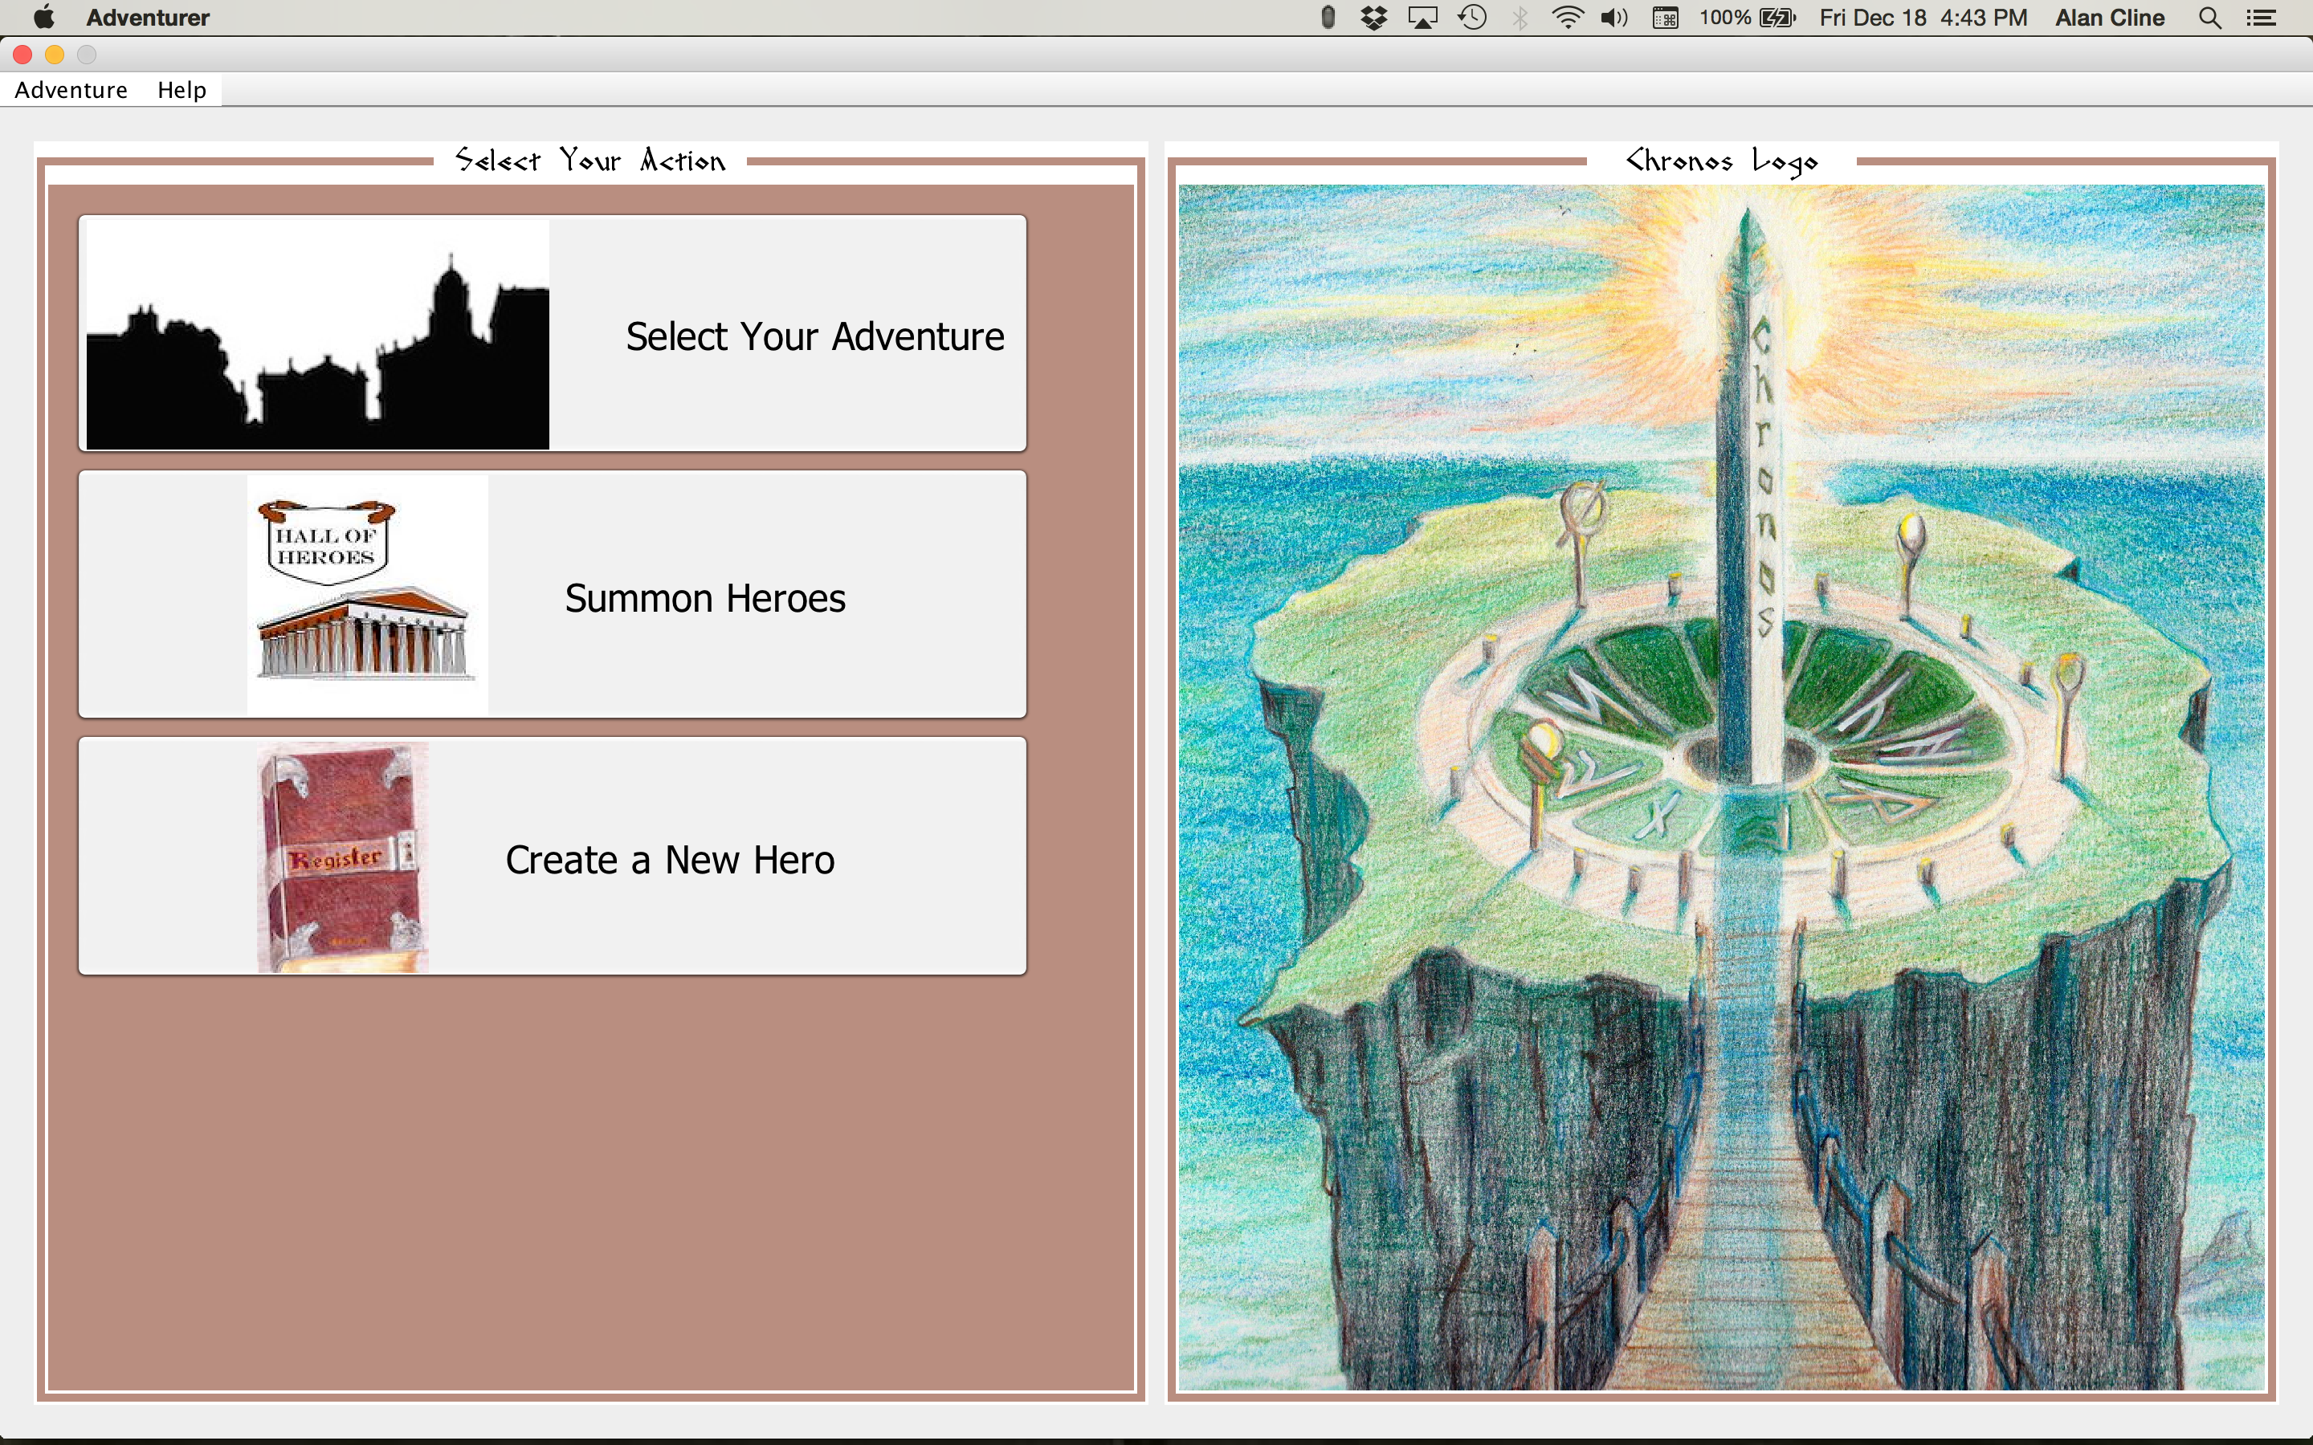

Figure 1. p00_MainActionPage

*Adventurer* starts with the a window frame and menu bar on top, three large buttons on the right, and the Chronos logo in the image panel. Note the *Adventurer* name in the title bar. This frame is not moveable or resizable.

|  |  |
| --- | --- |
| **ACTION** | **RESPONSE** |
| Adventurer -> Quit: | Terminates the program (same as red button in frame) with confirmation prompt. |
| Help -> Help or F1 key | Displays general help in a resizable, moveable window. |
| Help -> About: | Displays a small dialog for program details and credits. |

**BUTTONS:**

**Select Your Adventure**: Displays a dropdown list of saved selectable adventures. Currently only the default adventure “Quest for Rogahn and Zelligar” is available. See Use Case “Open Adventure”.

**Summon Heroes**: Opens the dormitory where all Heroes are stored. From the resulting selection dialog, the user may retrieve a saved Hero (Summon), or rename or delete an existing Hero. See the respective use cases Summon Hero, Rename Hero, or Delete Hero.

**Create New Hero**: Creates a new Hero and saves it in the Dormitory. See Use Case Create New Hero.